# Starting Eclipse IDE

On starting Eclipse for the first time, the following pop-up window will appear. Select a workspace directory and click on Launch.

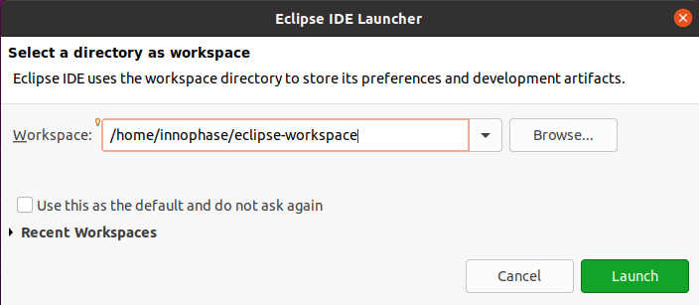

Figure 8: Selecting a workspace directory

It is recommended to create a unique workspace that will be used exclusively for the projects related to the GCC toolchain. The workspace selected should not have a path name that is excessively long, and it is best to avoid spaces in the path name.